CTS NURTURE 4.0_ JAVA FSE:

#WEEK 3

#EXERCISE 2:

# DIFFERENCE BETWEEN JPA, HIBERNATE AND SPRING DATA JPA:

**JPAHibernateSpringDataJpaDemoApplication**

**Location: com.cts.nurture**

package com.cts.nurture;

import org.springframework.boot.SpringApplication;

import org.springframework.boot.autoconfigure.SpringBootApplication;

@SpringBootApplication

public class JPAHibernateSpringDataJpaDemoApplication {

public static void main(String[] args) {

SpringApplication.run(JPAHibernateSpringDataJpaDemoApplication.class, args);

}

}

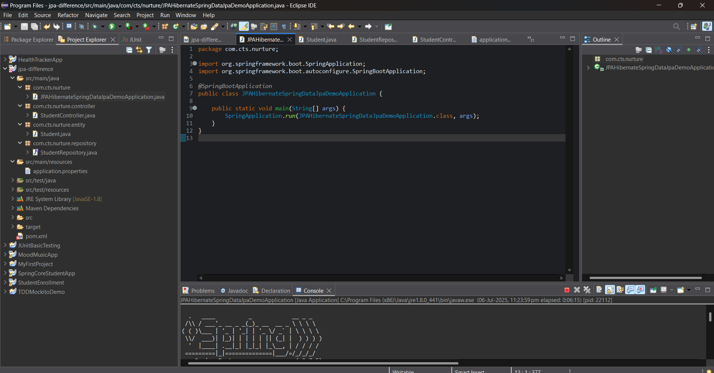

**StudentController.java**

**Location: com.cts.nurture.controller**

package com.cts.nurture.controller;

import com.cts.nurture.entity.Student;

import com.cts.nurture.repository.StudentRepository;

import org.springframework.beans.factory.annotation.Autowired;

import org.springframework.web.bind.annotation.*;

import java.util.List;

*@RestController*

*@RequestMapping*("/students")

public class StudentController {

*@Autowired*

private StudentRepository repository;

*@PostMapping*

public Student saveStudent(*@RequestBody* Student student) {

return repository.save(student);

}

*@GetMapping*

public List<Student> getAllStudents() {

return repository.findAll();

}

}

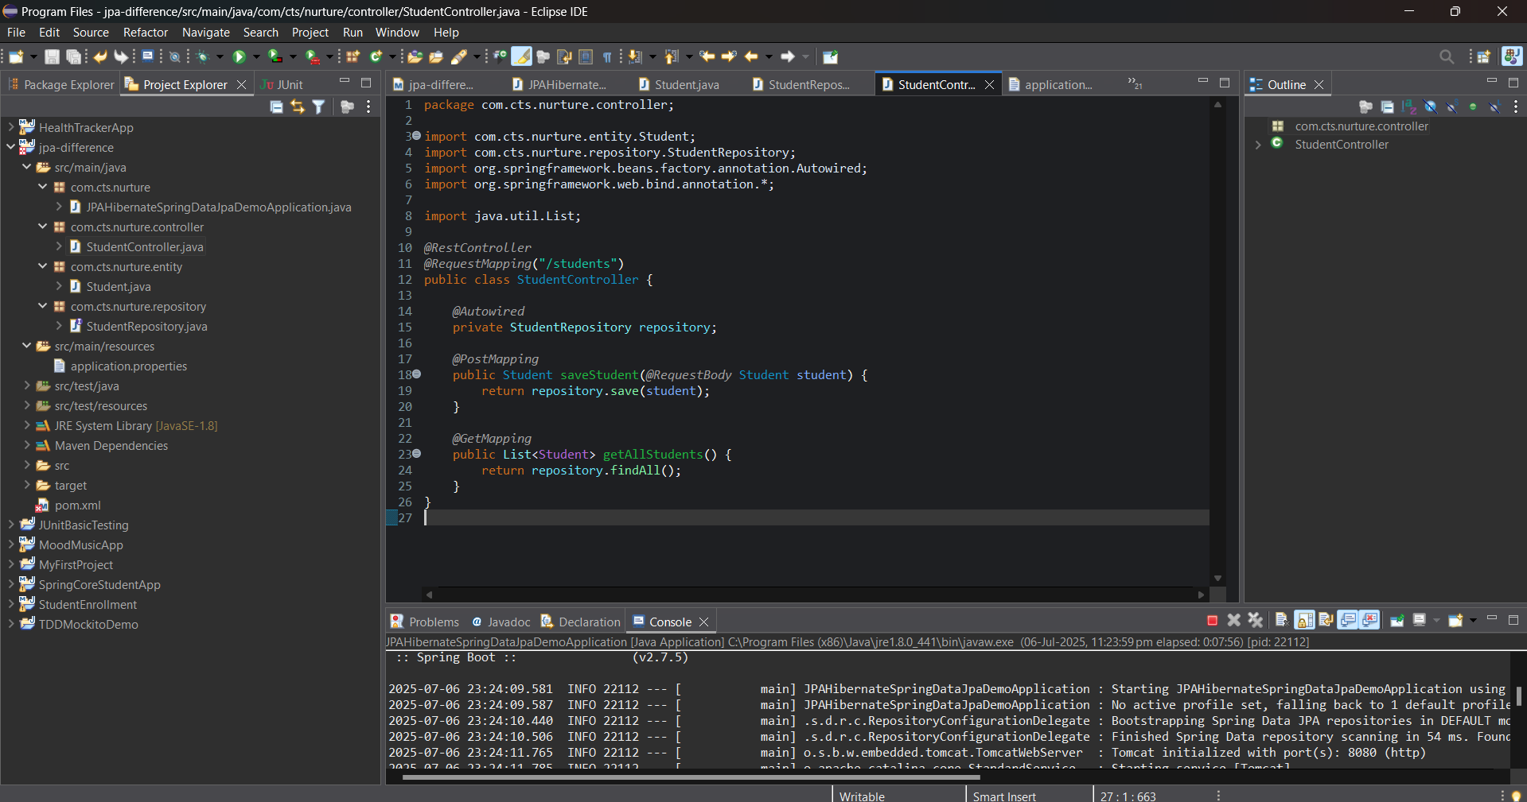

**Student**

**Location: com.cts.nurture.entity**

package com.cts.nurture.entity;

import javax.persistence.*;

*@Entity*

public class Student {

*@Id*

*@GeneratedValue*(strategy = *GenerationType*.***IDENTITY***)

private Long id;

private String name;

private String department;

// Getters and Setters

public Long getId() {

return id;

}

public void setId(Long id) {

this.id = id;

}

public String getName() {

return name;

}

public void setName(String name) {

this.name = name;

}

public String getDepartment() {

return department;

}

public void setDepartment(String department) {

this.department = department;

}

}

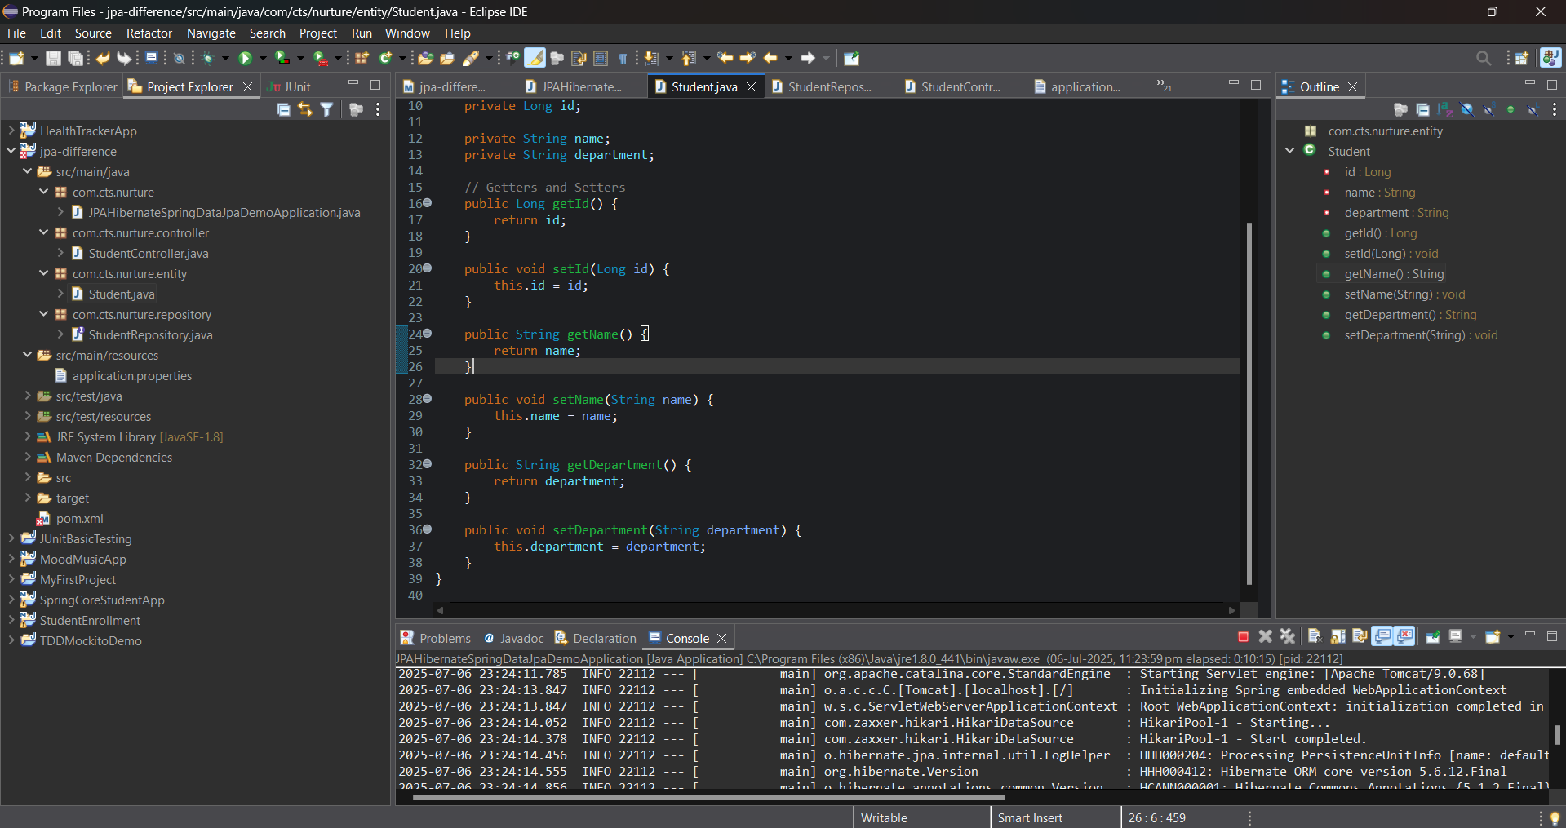

**StudentRepository**

**Location: com.cts.nurture.repository**

package com.cts.nurture.repository;

import com.cts.nurture.entity.Student;

import org.springframework.data.jpa.repository.JpaRepository;

public interface StudentRepository extends JpaRepository<Student, Long> {

}

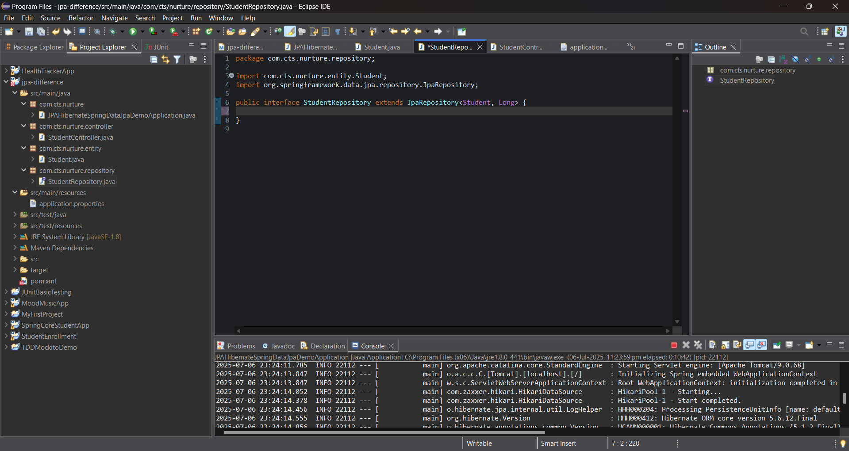

**application.properties**

**Location: src/main/resources/application.properties**

# DataSource Config (H2 DB)

spring.datasource.url=jdbc:h2:mem:testdb

spring.datasource.driverClassName=org.h2.Driver

spring.datasource.username=sa

spring.datasource.password=

# Hibernate Config

spring.jpa.hibernate.ddl-auto=update

spring.jpa.show-sql=true

spring.jpa.database-platform=org.hibernate.dialect.H2Dialect

# H2 Console

spring.h2.console.enabled=true

spring.h2.console.path=/h2-console

